Всероссийская олимпиада школьников. 2019-2020 уч.год. Английский язык. 7 класс. Школьный тур.
Enjoy the competition and good luck to you!

Задание 1. Аудирование
Прослушайте текст дважды и решите, какие из утверждений верные (True), неверные (False) и о чем в тексте не говорится (Doesn’t say).
1. The new library opened two days ago.
2. Robert found out about the library from his cousin.
3. It is light inside the new library.
4. The library has very modern computers.
5. Visitors can look at e-books on every floor.
6. To join the library students must bring a photograph.
7. Robert is planning to join the library.
8. The library is less than 200 metres from the nearest bus stop.

Задание 2. Чтение.
Прочитайте текст и выполните задания:
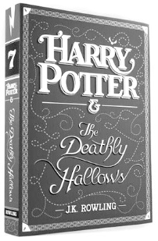
J.K. Rowling (Joanne Rowling) is a British novelist and the author of the Harry Potter fantasy series. As a child, Joanne dreamt of being a writer and made up fantasy stories that she read to her sister and her classmates. Her talent for telling stories made her a popular figure in the school. During breaks between lessons, she was often surrounded by a crowd of friends, who couldn’t wait to hear the latest story she had written.
Twelve publishing houses said ‘no’ to the first Harry Potter book before it was published in 1997. At that time Rowling had no job and when a publisher said ‘yes’ she became rich and famous overnight.
Then there were six sequels, the last in 2007.The books have won many awards and have become the basis for a series of eight films.
The Harry Potter novels have become the best-selling book series in history breaking all sales records: Harry Potter and the Deathly Hallows sold 11 million copies on the first day of release in the United Kingdom and United States. The series, totalling 4,195 pages, has been translated into 65 languages.
In 2015 the play Harry Potter and the Cursed Child was published. It is the eighth book in the series, and it tells the story of the life of Harry Potter's youngest son Albus nineteen years after the events of the seventh book. The play was first staged in one of London theatres in 2016.
In 2001 Rowling wrote Fantastic Beasts and Where to Find Them, a book about the magical creatures in the Harry Potter world. The main character is Newt Scamander and the story is set in New York City, 70 years before Harry's story started. The book gave the idea for a series of films, the first and second of which were released in 2016 and 2018. There will be three more films and Rowling is the screenwriter.
Since the Harry Potter series, Rowling has written some books for adult readers under the pen name Robert Galbraith.
Соотнесите части предложений:
1. Albus  2. The Harry Potter novels  3. The first Harry Potter book  4. Harry Potter and the Cursed Child  5. J.K.Rowling and Robert Galbraith  6. School was where | A. came out more than 20 years ago.  B. is not a novel.  C. are the same person.  D. J.K. Rowling had her first fans.  E. is the main character of Harry Potter and the Cursed Child.  F. can be read in 65 languages.
Задание 3. Грамматика
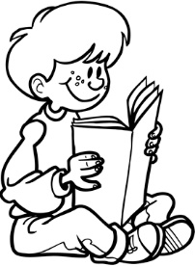
Выберите единственно правильный вариант:
1. For Simon ____ is as exciting as reading.
a) anything b) nothing c) everything d) something
2. Simon ____ not read all the books from his home library yet.
a) does b) is c) has d) will
3. Simon’s friends always give ____ books for ____ birthday.
a) his, him b) him, him c) his, his d) him, his
4. Last year he ____ some on-line libraries.
a) joined b) was joined c) has joined d) was joining
5. Now he ____ download many e-books for free.
a) should b) can’t c) can d) must
6. Simon thinks ____ is great that a lot of reviews can be found on the Internet.
a) there b) this c) it d) -
7. He never downloads a book ____ reading other people’s opinions about it.
a) after b) from c) by d) without
8. Now Simon ____ with the characters of a new adventure book.
a) is travelling b) travels c) travel d) has travelled
9. He always_____ a great time with a book.
a) takes b) has c) spends d) finds

